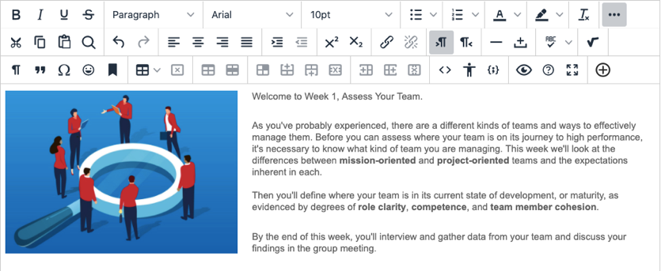
The Updated Content Editor in Blackboard Learn:
Original Experience, Original Course View

There are lots of great reasons to like the updated Content Editor. Adding content has been simplified, and it works better on both hand-held devices and larger screens. There are several improvements for accessibility and some new features, too. Here are just six enhancements.

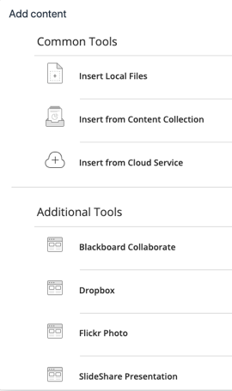
The Power of Plus
One easy menu for adding content from your computer, cloud storage, or integrated tool. The Content Editor will automatically recognize the kinds of files you add.

Better for All Devices
The editor is better suited for all devices—small screen or big. Pop-ups are gone for a better mobile experience.

Improved Accessibility
The editor is more accessible, and a new accessibility checker helps authors make content more accessible.

Better Copy and Paste
Pasting content from Word, Excel, and websites is even better. You can choose to remove extra HTML but retain basic formatting.

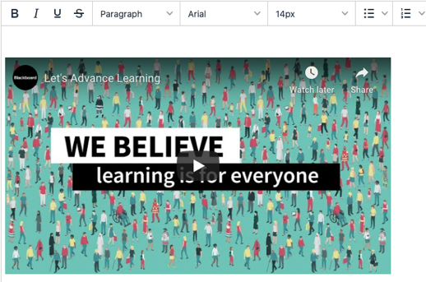
Simple Embed
When pasting links to websites such as YouTube, Vimeo, and Dailymotion, the videos are automatically embedded for inline playback. Other sites including The New York Times, WordPress, SlideShare and Facebook will embed summary previews.

Display Computer Code
Authors can now share formatted computer code snippets, super handy for computer science classes and coding clubs.
an now limit your search just to content that’s been selected.

