Multi-Factor-Authentication (MFA) For your security
At Ottawa University we take your security very seriously. We have implemented Multi-Factor Authentication for several programs used by Ottawa University. Below is a link to install the app on a smartphone. Please reach out if you have any trouble at all.
On your computer, go to office.com and sign in. You will receive the More Information Required prompt after entering your email and password. Click next and follow the prompts until you receive a QR code. Scan this QR code with the Authenticator App on your phone.
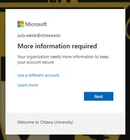
The first step is to install the app on your cell phone. If you have already downloaded the Microsoft Authenticator app O
On the computer screen click Next twice
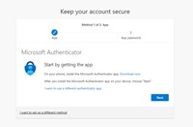
On your Phone Download the Authenticator App by Microsoft on your phone.
Open the Authenticator App and press the + button to add your account.
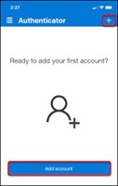
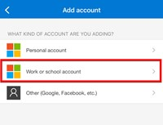
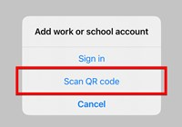
On the Computer
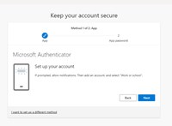
Use the Microsoft Authenticator app on your phone to scan the QR code on the computer screen. Click Next on the computer when the account is added to the app on your phone.
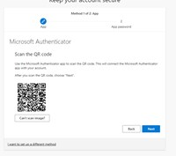
Your phone should prompt you to enter the number you see on the computer screen and verify you are you using your fingerprint, face or whatever security set up on your phone.
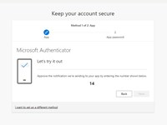Click Next
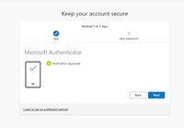
enter enough text to satisfy the request, and click next. *This is a feature we are not using, you will never be asked to recall this information.
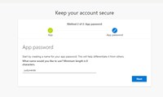
Click Next
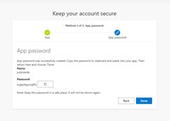
Click DONE!
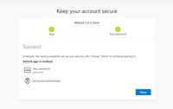
You should be at this prompt, if you are on your own device, staying logged in is not a security risk. If you are on a shared device always choose no on this screen.
