|  |
| --- |
| PPE LEAGUE  COMPETITION |

# 

# 

# **Preparation – Practice - Gameday**

# **Preparation and Practice**

## **Readings and other material**

Each team member should read the materials for the event and watch any videos that were included. Teams should hold discussion groups or find other ways to assure there is an understanding of the material prior to competition. Understanding the material will be especially important for the Policy Case Competition and Commercial.

## **Survey**

The survey is the start of each of the team’s journeys in the PPE League competition.

Each team will be given the same 5 questions to ask other peers and students around their campus. Each survey should be recorded and documented.

The survey will help gauge the knowledge that your university has on the topic. It will also be a helpful tool in which direction to take your commercial. Student’s will receive survey questions related to this year’s topic in the next few weeks.

# **Commercial Creation**

The commercial is the first event in PPE League that is judged and scored for each team. This event is for the students to show their creativity and ability to educate the audience. The goal of this commercial is to teach your community and school about the topic. The survey helps students grasp the ideas that students are unaware of and can point them in the right direction towards a creative idea for a commercial. This commercial should have all the students involved and the video length should be 2-5 minutes. The video can go in any direction but should be able to help someone understand the year’s topic more than they previously had.

# **Video Game Practice**

The game competition this year will be Colonist.io. Colonist.io is a brilliant and challenging web-based board game that positions itself as an alternative to the highly popular Settlers of Catan board game. You must build a civilization and expand your territory. Building settlements increases your production and victory points, but it makes you a target for other players. Extremely simple rules with tremendously deep gameplay. Combine strategy, planning, and cunning negotiations to win.

Below is a link to a video on how to play Colonist.io:

Colonist has recently created an app for its game, allowing for students to practice wherever they may be! The app can be found on the Apple app store or on the Google Play store for free. We hope this will allow for students to learn on their own.

[Colonist io | How to Play Catan Online (youtube.com)](https://www.youtube.com/watch?v=XUcO2wYcIEY)

# **Events for Game Day**

## **1.Commercial Viewing and Judging**

The commercial will be judged and played in front of everyone the day of the competition. Each team should email a link or file to the host the day before the competition so that the host can prepare for viewing. Professor judges will use the following rubric to score each commercial. First place gets 4 points, second place gets 3 points, third place gets 2 points, and fourth place gets 1 point for their team.

The game will have 2-3 players from each team representing your school. The average time that the game lasts can vary with the rules in place, but below are the rule settings that we will be playing on. We will hide the bank cards, play the base map, and have the game speed be fast. The dice are set to random and 10 victory points to win. First place gets 4 points, Second place gets 3 points, Third place gets 2 points.

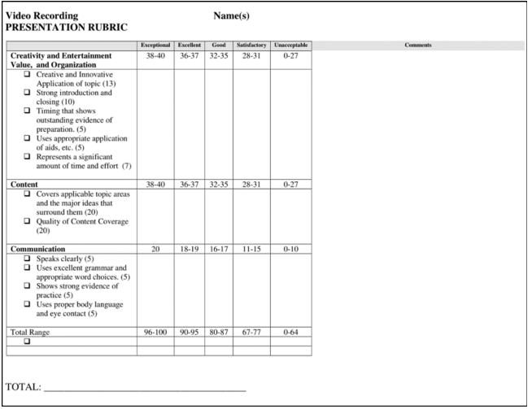

## **2. Game Theory**

In this part of the competition, participants will be paired up to play strategic economic “games”. This games will have simple rules, strategies, and payoffs with prizes for winning individuals and teams. There is no preparation necessary for this part of the competition and the specific game will be kept secret from the players until the start of the event. The players will be able to play with no former knowledge of game theory.

**Note: Two sets of teams will compete against each other. Depending on your team, you will either be starting with the video game competition or game theory competition immediately after presenting commercials of all teams.

**3. Video Game Competition**

As mentioned above, the video game competition for this year will utilize the online game colonist.io.

## **4.Policy Case Presentation**

The policy case competition encourages students to think critically, analytically, and creatively to present policy solutions to real issues. The prompt will be inspired by this year’s topic. Students are expected to have read and captured the information from the distributed reader, which is permitted for use during preparation times.

The Policy Case Competition will allow each team 15 minutes of prep time on their own in a secluded room. They will present immediately at the end of the 15 min and give a presentation being no longer than 10 minutes in front of our judges. Teams will have prepared ahead of time on the general theme, and a more specific question will be given to the students at the beginning of their preparation time. Students may bring the assigned readings for reference.

After the presentation, the judges will have an opportunity to ask some questions.

The rubric for judging has been included below.

